***Assignment 1***

***Conceptual Database Modelling***

***Name: Yang Yang Li (13763330)***

***Class: CP2404***

***Lecturer: Joanne Lee***

***Date:01/05/2020***

***College of Science and Engineering***

***James Cook University***

# **Brief discussion**

In order to complete this assessment, the steps are been followed:

1. Identify all the entities from the business scenario.
2. Identify the relationships between any pair entities.
3. If there are M:N relationships must be break downs in to two 1:M relationships; hence new bridging entity would be created.
4. Creating ERD (Entity Relationship Diagram).
5. Specify all attributes for each entity (primary key, foreign key etc.) in the ERD.
6. Make all tables in 3NF。
7. Identify optionality for each relationship in the ERD.
8. Specify weak/strong relationship in the ERD.
9. Review the business rules.
10. Review the final ERD.
11. Creates a summary that would describe the major justification, assumption and limitation of the data design

Problem:

When create the ERD, the optional relationship was very difficult to determine. And some of the entity table was confusing to determine is it a 3NF. Last, due to many entities must be fit in to one space it was difficult to show all entities and manages the relationship between entity.

# **Businesses rules**

**Entity: COMPANY**

A COMPANY owns one or many COLLEGEs.

**Entity: COLLEGE**

Each COLLEGE is owed by one COMPANY.

Each COLLEGE is organized by one or many DEPARTMENTs.

A COLLEGE employs zero or many STAFFs.

A COLLEGE runs a different STUDY_PERIOD.

Each COLLEGE is managed by only one STAFF.

A COLLEGE can owns zero or many EQUIPMENTs.

**Entity: STUDY_PERIOD**

Each STUDY_PERIOD is managed by one COLLEGE.

**Entity: DEPARTMENT**

The DEPARTMENTs have formed one COLLEGE.

Each DEPARTMENT can assign one or many STAFFs.

A DEPARTMENT is offering one or many COURSEs.

A DEPARTMENT runs one or many SUBJECTs.

A DEPARTMENT runs one or many same CLASSES.

A DEPARTMENT is managed by only one STAFF.

**Entity: STAFF**

A STAFF can employ by a COLLEGE.

A STAFFs may or may not assign to one DEPARTMENT.

Each STAFF is allocated to an OFFICE.

A STAFF may or may not advisor a STUDENT.

Each STAFF have zero or many ADVISOR records.

Each ADVISOR record is related to one STAFF.

A STAFF cannot advisor for more than 30 STUDENTs at the same time.

A STAFF can teach zero or many CLASSEs.

One of the STAFF can manages each COLLEGE.

One of the STAFF can manages each DEPARTMENT.

A STAFF can book zero or many EQUIPMENTs.

Each STAFF has zero or many STAFF_BOOKING.

Each STAFF_BOOKING is related to one STAFF.

**Entity: OFFICE**

An OFFICE is shared by one or many STAFF.

**Entity: COURSE**

Each COURSE is offered by only one DEPARTMENT.

A COURSE can be enrolled by zero or many STUDENTs.

Each COURSE has zero or many COURSE _LIST.

Each COURSE _LIST is related to one COURSE.

**Entity: STUDENT**

A STUDENT can enrol more than one COURSE.

Each STUDENT has one or many COURSE _LIST.

Each COURSE _LIST is related to one STUDENT.

A STUDENT can assign more than one STAFFs.

Each STUDENT has one or many ADVISOR records.

Each ADVISOR record is related to one STUDENT.

A STUDENT can assign more than one CLASS.

Each STUDENT has one or many CLASS_LIST.

Each CLASS_LIST is related to one STUDENT.

A STUDENT can have more than one SUBJECT.

Each STUDENT has one or many SUBJECT_LIST.

Each SUBJECT_LIST is related to one STUDENT.

A STUDENT can book zero or many EQUIPMENTs.

Each STUDENT has zero or many STUDENT _BOOKING.

Each STUDENT _BOOKING is related to one STUDENT.

Each STUDENT has one STUDENT_ACADEMIC_INFORMATION recorded.

Each STUDENT has one STUDENT__PERSONAL_INFORMATION recorded.

**Entity: STUDENT_ACADEMIC_INFORMATION**

Each STUDENT_ACADEMIC_INFORMATION record is related to one STUDENT.

**Entity: STUDENT__PERSONAL_INFORMATION**

Each STUDENT__PERSONAL_INFORMATION record is related to one STUDENT.

**Entity: SUBJECT**

A SUBJECT is run by one DEPARTMENT.

A SUBJECT can have one or many CLASSEs.

Each SUBJECT can have one or many PREREQUISITEs.

Each SUBJECT has at least one SUBJECT_STUDY_TEXT(SST) and up to 3 SUBJECT_STUDY_TEXT(SST)s.

A SUBJECT can be enrolled by zero or many STUDENTs.

Each SUBJECT has zero or many SUBJECT_LIST.

Each SUBJECT_LIST is related to one SUBJECT.

**Entity: SUBJECT_STUDY_TEXT(SST)**

A SUBJECT_STUDY_TEXT(SST) is related to one SUBJECT.

**Entity: PREREQUISITES(P)**

A PREREQUISITES(P) is related to one SUBJECT.

**Entity: CLASS**

Each CLASS is assigned by one SUBJECT.

A CLASS can be taught by a different STAFF.

A CLASS can be enrolled by zero or many STUDENTs.

Each CLASS has zero or many CLASS_LIST.

Each CLASS_LIST is related to one CLASS.

**Entity: EQUIPMENT**

An EQUIPMENT can book by zero or many STAFFs.

Each EQUIPMENT has zero or many STAFF_BOOKING.

Each STAFF_BOOKING is related to one EQUIPMENT.

An EQUIPMENT can book by zero or many STUDENTs.

Each EQUIPMENT has zero or many STUDENT _BOOKING.

Each STUDENT_BOOKING is related to one EQUIPMENT.

An EQUIPMENT is owned by one COLLEGE.

# **Entity relationship diagram (ERD)**

***Figure 1: ERD - ABCE***

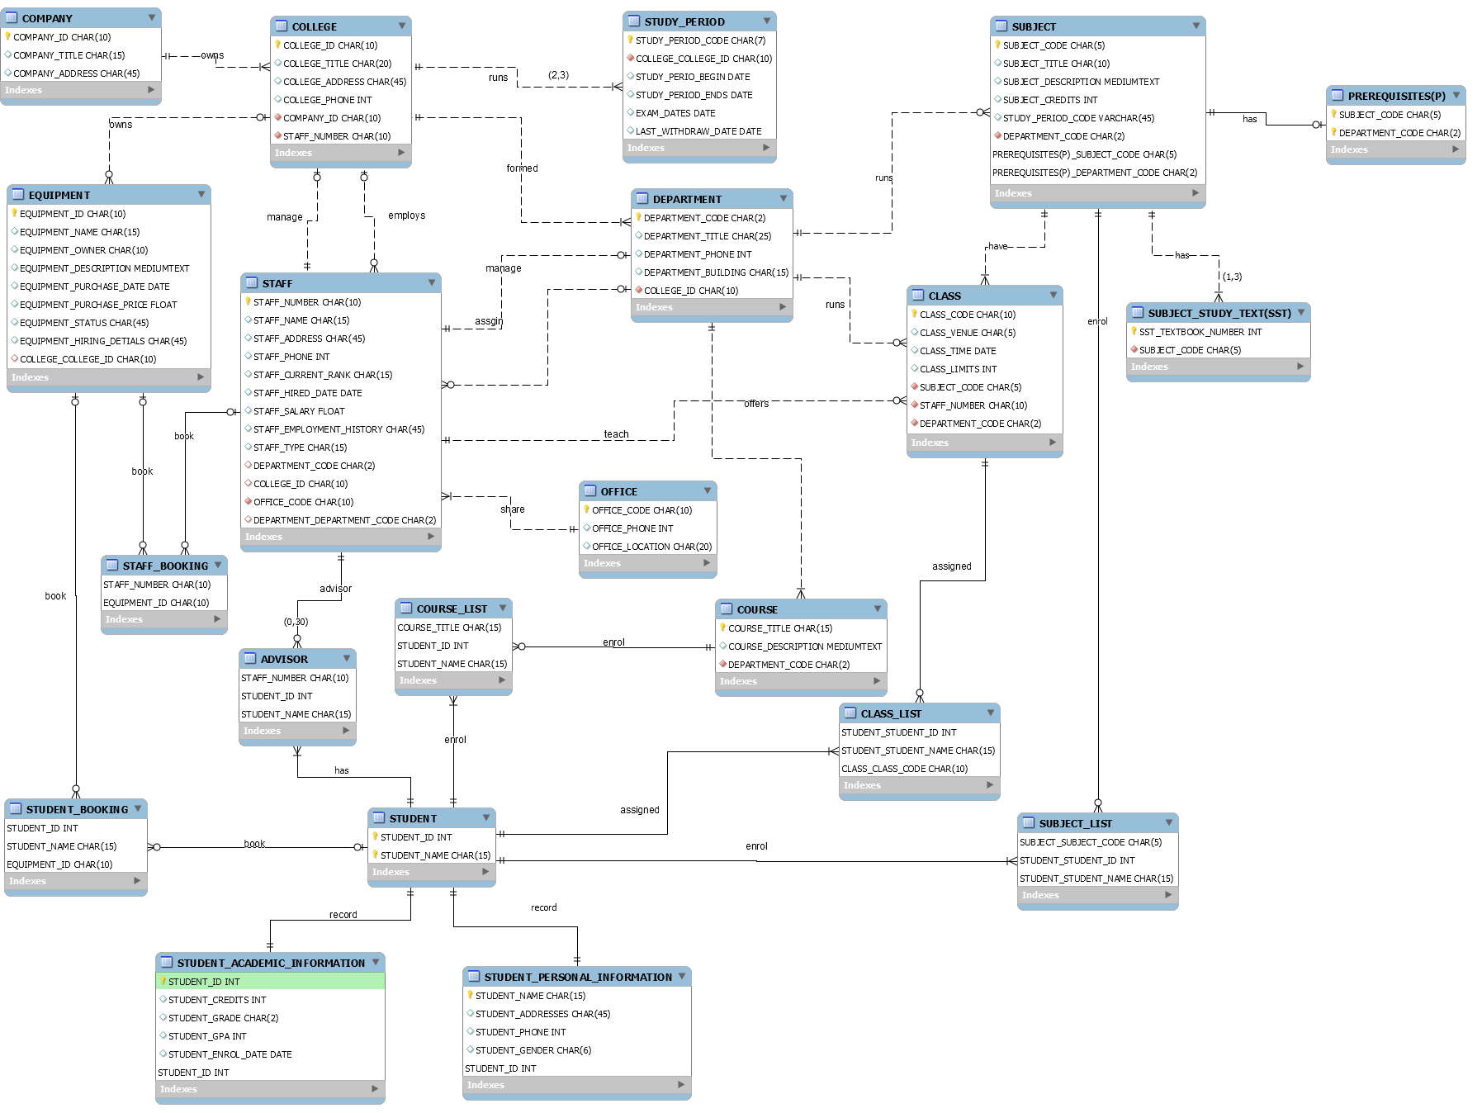

# **Summary**

Assumptions:

* A college can employs zero or many staffs since the department may employ staffs.
* A college can owns zero or many equipment since the college does not required one due to its too small.
* A staff can have zero or many students since the staff may be an administrative staff not an academic staff.
* A staff can book zero or many equipment since the staff may already have its own equipment.
* A staff can have zero or many classes since the staff may be an administrative staff not an academic staff.
* A staff may or may not assign to a department since the staff may be an administrative staff not an academic staff.
* A course can enrol zero or many students since that particular year’s students may not interested to this course.
* A student can book zero or many equipment since the student may already have its own equipment.
* A subject can have zero or many students since that particular year’s students may not interested to do this subject and it’s not prerequisite so he can do it next year.
* A class can be enrolled by zero or many students since that class is not open this semester and will be open next semester.
* An equipment can book by zero or many staffs and students since that staffs and students already has it.

The two entity STUDENT__PERSONAL_INFORMATION and STUDENT_ACADEMIC_INFORMATION been separate form STUDENT entity it reduces management complexity and avoid structural dependence.